**Final Report**

**BT&T**

**Github:** <https://github.com/DevlinHamill/cs460GroupProject.git>

**Team Members:**

Devlin H.

Aty S.

Josh M.

Cassie T.

# Adherence to original deign

For our implementation we made sure to stay on the line of the design as much as possible for example the application has a sign in page which was discussed in the original design document. However a sign up page has been added to allow for new members to join the club/ organization. Furthermore, we made sure to include the hub and combined both the members list and messaging system similar to how a previous lab is. Thus, the only change to the hub would be 4 buttons total instead of 5. Permissions were slightly change so the user and officers cant see the finance button and the treasurer cannot access the messaging system based on how they are only interested in, while presidents can access everything. Allowing for the specific roles to be represented on the application much like the hubs initial design. The calendar is also the same as the initial design, however we added a more detailed description of each meeting description bellow said calendar, we also added the ability to remove meetings and click on a specific date on said calendar to see if it has a meeting. Furthermore, the members list is the same however it does not display the roles, and it does not display the treasurer as a result of how the treasurer cannot see the messaging system. Allowing for other users to communicate with other club/organization members rather then being discouraged based on seeing higher roles. Users can also see all message data and any history they have with a specific organization member. Allowing the member to keep track of important conversations and keep the context of the conversation. Furthermore, the finance page has the same functionality such as allowing the users to see all expenses and income from said club/organization as well as buttons to manipulate the total such as adding an expense or adding an income value. Expenses and income values cannot be directly removed however as a result of how the treasurer needs to see all statements that resulted in the total they can continue to add to it if they need to add or subtract from the total. Lastly, the profile section works similar to the previous design, however it contains less data, the profile will only display the first and last name of the user, the picture and the email and will NOT display the users role as a result of how the user will know their role. They can also sign out via the profile if the user wants to exit the app or switch accounts.

# Project Description

For our Project we decided to create a club/organization application that helps with the very tasks associated with a team-based environment. For example, a existing user can sigh in via the a the sigh in page. They are also allowed to sign up to the application via the sign up page upon which they will be given a permission level of 1 were they are cut off from creating announcements and seeing the finance page as a result of being a new user.

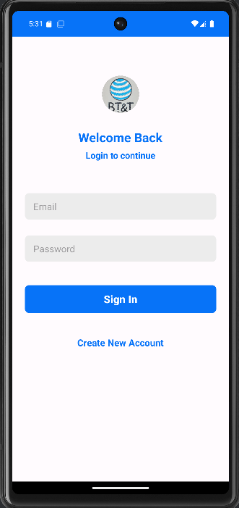

The user will then be brought to a hub page which will provide access to various buttons such as the calendar button, message button, finance button and profile button. The view of this is changed depending on the user for example officers and new members cannot access the finance page, while a president can see everything and a treasurer cannot see the message system from how they are mainly concerned with the finance, calendar and their own profile. Every single function associated with the hub also contains a back button that allows for the user to revisit other hub functions if necessary.

**Treasurer View**

**President View:**

**New member & Officer view**

Upon clicking on the Callender button, they are brought a Callender with a list of all meeting that exists. If the user is not a new user they can click on a specific date and click on the add meeting button to add a meeting with a title, time and a description. They can also click on a meeting in the meeting list which will be surrounded by a grey color this allows the user to remove said meeting if they click on the remote meeting(s) button.

**New User Calendar**

**Other user calendar view**

**Adding meeting:**

**Viewing multiple meetings**

**Clicking on a specific date that has a scheduled meeting clicking on the meeting and remove said meeting**

After clicking on the messaging button in the home page they are brought to a members list where they can the click on a specific user and start chatting with them or continue an existing conversation. Conversations can be me made by or sent to any member besides the treasure who does will not access said features due to the role being a facility member instead of a club member.

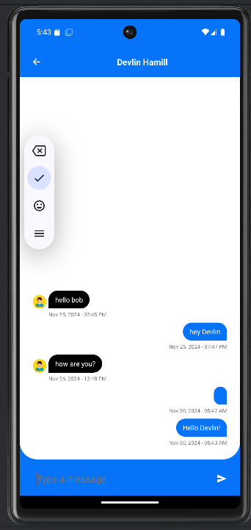

When clicking on the finance button which is visible for the president and treasurer role, the users will be able to see all finances such as expenses and income which will add or take away from the club’s total income displayed bellow. The user will be able to add and expense or piece of income to the total but not remove the statement as all statements need to be tracked so the treasurer knows about all statements that were added to the club/organization funds.

Lastly upon click on the profile button the user can see their information such as their first name, last name, email, and profile picture. They could also sign out of their profile if they desire to exit the application or switch accounts.

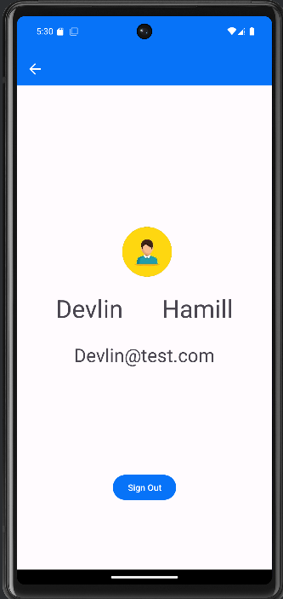

# Testing

Through rigorous testing is seems the only issues that really occur is when a person is streaming the emulator. For whatever reason streaming somehow mixes with the emulators processes and causes it to crash somewhat, this was originally caused by a final() method being called however this was fixed and still for whatever reason has a chance of crashing the application. Without streaming it runs perfectly fine with no issues. The only issue I would say for this application however is some logical problems for example a user could create a fake account but they would not be able to access anything. This could be fixed through adding a member management button for the president for a future improvement.

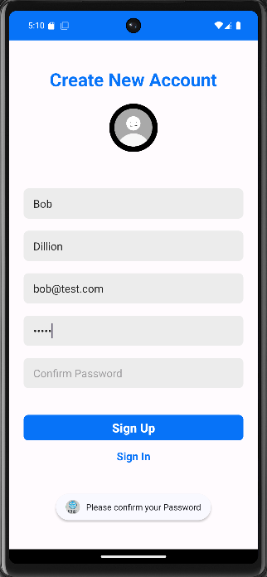

Treasurer view

president view new user and officer view

new user view other user’s view

